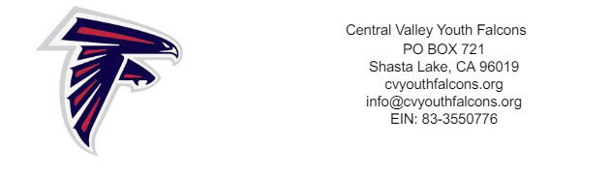

Dear Potential Sponsor,
Central Valley Youth Falcon Football and Cheer would greatly appreciate your support during this season. The Youth Falcon Football/Cheerleading League is a local recreational non-profit program that participates in the Sacramento Youth Football program. Our organization serves approximately 180 families in our community. We offer boys and girls ages 6-14 the opportunity to participate in football or cheerleading as recreation and as a means to develop sportsmanship, teamwork, responsibility, and respect for their community.
The Central Valley Youth Falcons Football & Cheer organization serves as a high school athletics preparatory program, and strives to cultivate positive community involvement. The organization promotes the importance of success for youth athletes, in competition, in the home, and in the classroom. We hope you will consider becoming a proud sponsor of a Central Valley Youth Falcon athlete.
Football registration fee is $325
Cheer registration fee is $435
Name of Athlete ________________________________________________
Name of Sponsor___________________________________________________________
Sponsor Address___________________________________________________________
Sponsor Phone_______________________
Sponsorship Amount $___________________

Thank you for supporting the Central Valley Youth Falcons!
Make Checks Payable to CVYF. Please keep a copy of this form for your records

The mission of the Central Valley Falcons Youth Football & Cheer organization is to facilitate a physical fitness program where young athletes can develop a sound mind, fitness, and good moral character. Through personal effort, teamwork, sound discipline, and accountability, athletes are encouraged to adopt the values of self respect, respect for others, and respect for rules, which can have an enormous positive impact in life, both in the present and in the future.

